PHSE
In Personal, Health, Social and Emotional education we will be looking at our families.

RE
Our RE focus this half term will be looking at ‘Why do some people think that life is a journey?’ and ‘What significant experiences mark this?’. We will explore this Through exploring baptism, Bar and Bat Mitzvah or Hindu Samskaras and marriage pupils explore how and why people chose to mark significant moments in life.

Year 4
curriculum

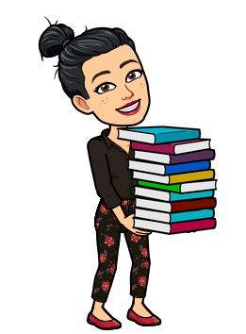
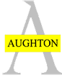
English
Our new class text is The Lion, The Witch and the Wardrobe. We are beginning our writing with writing the ending to the chapter we have read. We will explore the characters and using inverted speech marks for the character’s speech.
Geography
Our Geography will be all about looking at what different parts of the world are like and comparing England to South America. This will include exploring Brazil, Rio De Janeiro, the Amazon Rainforest and the life of the indigenous people.
Science
Our science will link with geography this term through our lesson on “What can be done to protect the rainforest?”.
This will draw on our skills and knowledge of deforestation from Autumn 2 Science.
Computing
Our focus in computing this half term will
be to use powerpoint. We will choose one
of our curriculum subjects to make a presentation.
DT
DT will be linked with maths this half term where we will use the budgeting with money to create a packaging for a product. The pupils will use their mathematical knowledge to work out how much money they need to make the packaging.
Maths
Multiplying 2 digits by 1 digit
Budgeting with money problems
Perimeter and area
Time
Interpreting data

Art
In Art this term we will exploring within our South America Geography unit to look at art work by Frida Kahlo. This is will include her childhood, what inspired her and her most famous art pieces. We will create one in her style.
History
In History this term we will be researching Britain's settlement by Anglo-Saxons & Scots. We will find out who they are, what they did, why they had long boats, was Alfred really ‘great’ and compare their lives to the Romans.

Home Learning
The homework will be set through the Google Classroom where you can send your learning direct to Miss Robinson and Miss White.
The home learning page will include;
Daily Practise – reading, spellings and times tables.
Key Reading Skills
Maths
English
And one curriculum subject.
Useful links
www.ttrockstars.com
www.spellingshed.com
www.mymaths.com
www.oxfordowl.co.uk
https://www.bbc.co.uk/bitesize/levels/zbr9wmn
www.educationcity.com
www.thenational.academy.co.uk

Music
South America will be our focus for Music this term where we will explore samba music, pulse and rhythm, rhythmical breaks and how to combine different versions of motifs.
PE
PE will focus on athletics and outdoor adventure activities this half term and we are very lucky to receive specialist teaching from Miss Murray for PE.
Modern Foreign Languages – French
Pupils will be learning how to talk about the parts of the face, parts of the body, colour revision and they will create and describe a monster.
During these lessons they will learn the skill of giving an opinion in French too.

