PHSE
In Personal, Health, Social and Emotional education we will be learning all about ‘What are families like?’ and how everyone is individual.

RE
Our RE focus this half term will be looking at ‘Why do some people think that life is a journey?’ and ‘What significant experiences mark this?’. We will explore this Through exploring baptism, Bar and Bat Mitzvah or Hindu Samskaras and marriage pupils explore how and why people chose to mark significant moments in life.

Year 4
curriculum

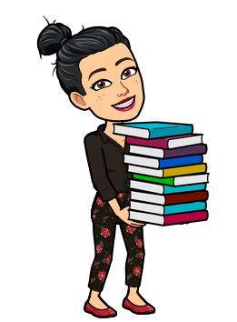
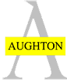
English
We are continuing to write our persuasive advert when we return before we spend a week writing a special Remembrance poem for Remembrance Day. We will then write one more piece as our final Firework Maker’s Daughter piece.
Geography
Our Geography will be all about ‘Who are my fellow humans?’ In this enquiry we will be looking at the United Kingdom and our neighbours in the continent Europe. This will deepen the pupil’s knowledge of wider world beyond our country.
Science
We will be exploring classification in Science this half term by looking at our school environment and the habitats around our school grounds. We will look at how habitats are made and the impact humans have on these. We will also be able to answer the question - What are vertebrates and invertebrates?.
Computing
Search Technologies is our focus for this half term and we will learn how to use the different elements of the internet to help us research information.
DT
DT will be linked with Art this half term as we will create the structure, building or bridge for our Mosaic pieces to go on.
Maths
A short recap of money to apply our maths skills from Autumn term 1.
Roman Numerals
Telling the Time
Classification of Shapes
Recall of formal methods – column method
Multiplying by 1 and 0.
Dividing by 1.

Art
In Art this term we will be researching Anthoni Gaudi who produced incredible Mosaic pieces linked to the Romans.
History
History this term will be a recap of Romans linked with our Art and Music enquiries.

Home Learning
The homework will be set through the Google Classroom where you can send your learning direct to Miss Robinson and Miss White.
The home learning page will include;
Daily Practise – reading, spellings and times tables.
Key Reading Skills
Maths
English
And one curriculum subject.
Useful links
www.ttrockstars.com
www.spellingshed.com
www.mymaths.com
www.oxfordowl.co.uk
https://www.bbc.co.uk/bitesize/levels/zbr9wmn
www.educationcity.com
www.thenational.academy.co.uk

Music
Linked to our history enquiry from last half term we will be listening to the Imperium Romanum.

PE
PE will focus on invasion games this half term and we are very lucky to receive specialist teaching from Miss Murray for PE.
Modern Foreign Languages – French
Pupils will be learning how to talk about the weather, sports and Christmas in French this half term.
During these lessons they will learn the skill of giving an opinion in French too.

