Our Foundation Stage Aims  - To provide a happy and secure environment that will stimulate a child’s curiosity and enthusiasm to play, explore and learn.  - To ensure all children are valued and that there is equal opportunity for every child regardless of their learning needs, culture, race, gender or religion, and to foster a mutual respect of others.  - To develop an effective partnership with parents and carers, and to build upon the invaluable foundations of learning already taking place at home. We want to involve you fully in your child’s education right from the start.  - To help each child to feel happy, independent, confident, accepted and included enabling him/her to establish purposeful relationships and friendships with adults and children.  - To make playing and learning memorable, exciting, challenging and most importantly FUN! |  |  | Aughton Junior Academy  Turnshaw Avenue  Sheffield  S26 3XQ  How to Contact Us  0114 2873091  info@aughtonacademy.org  www.aughtonacademy.org  Striving for  Excellence  Empowering  Achievement |  |   Aughton Junior Academy  Foundation Stage  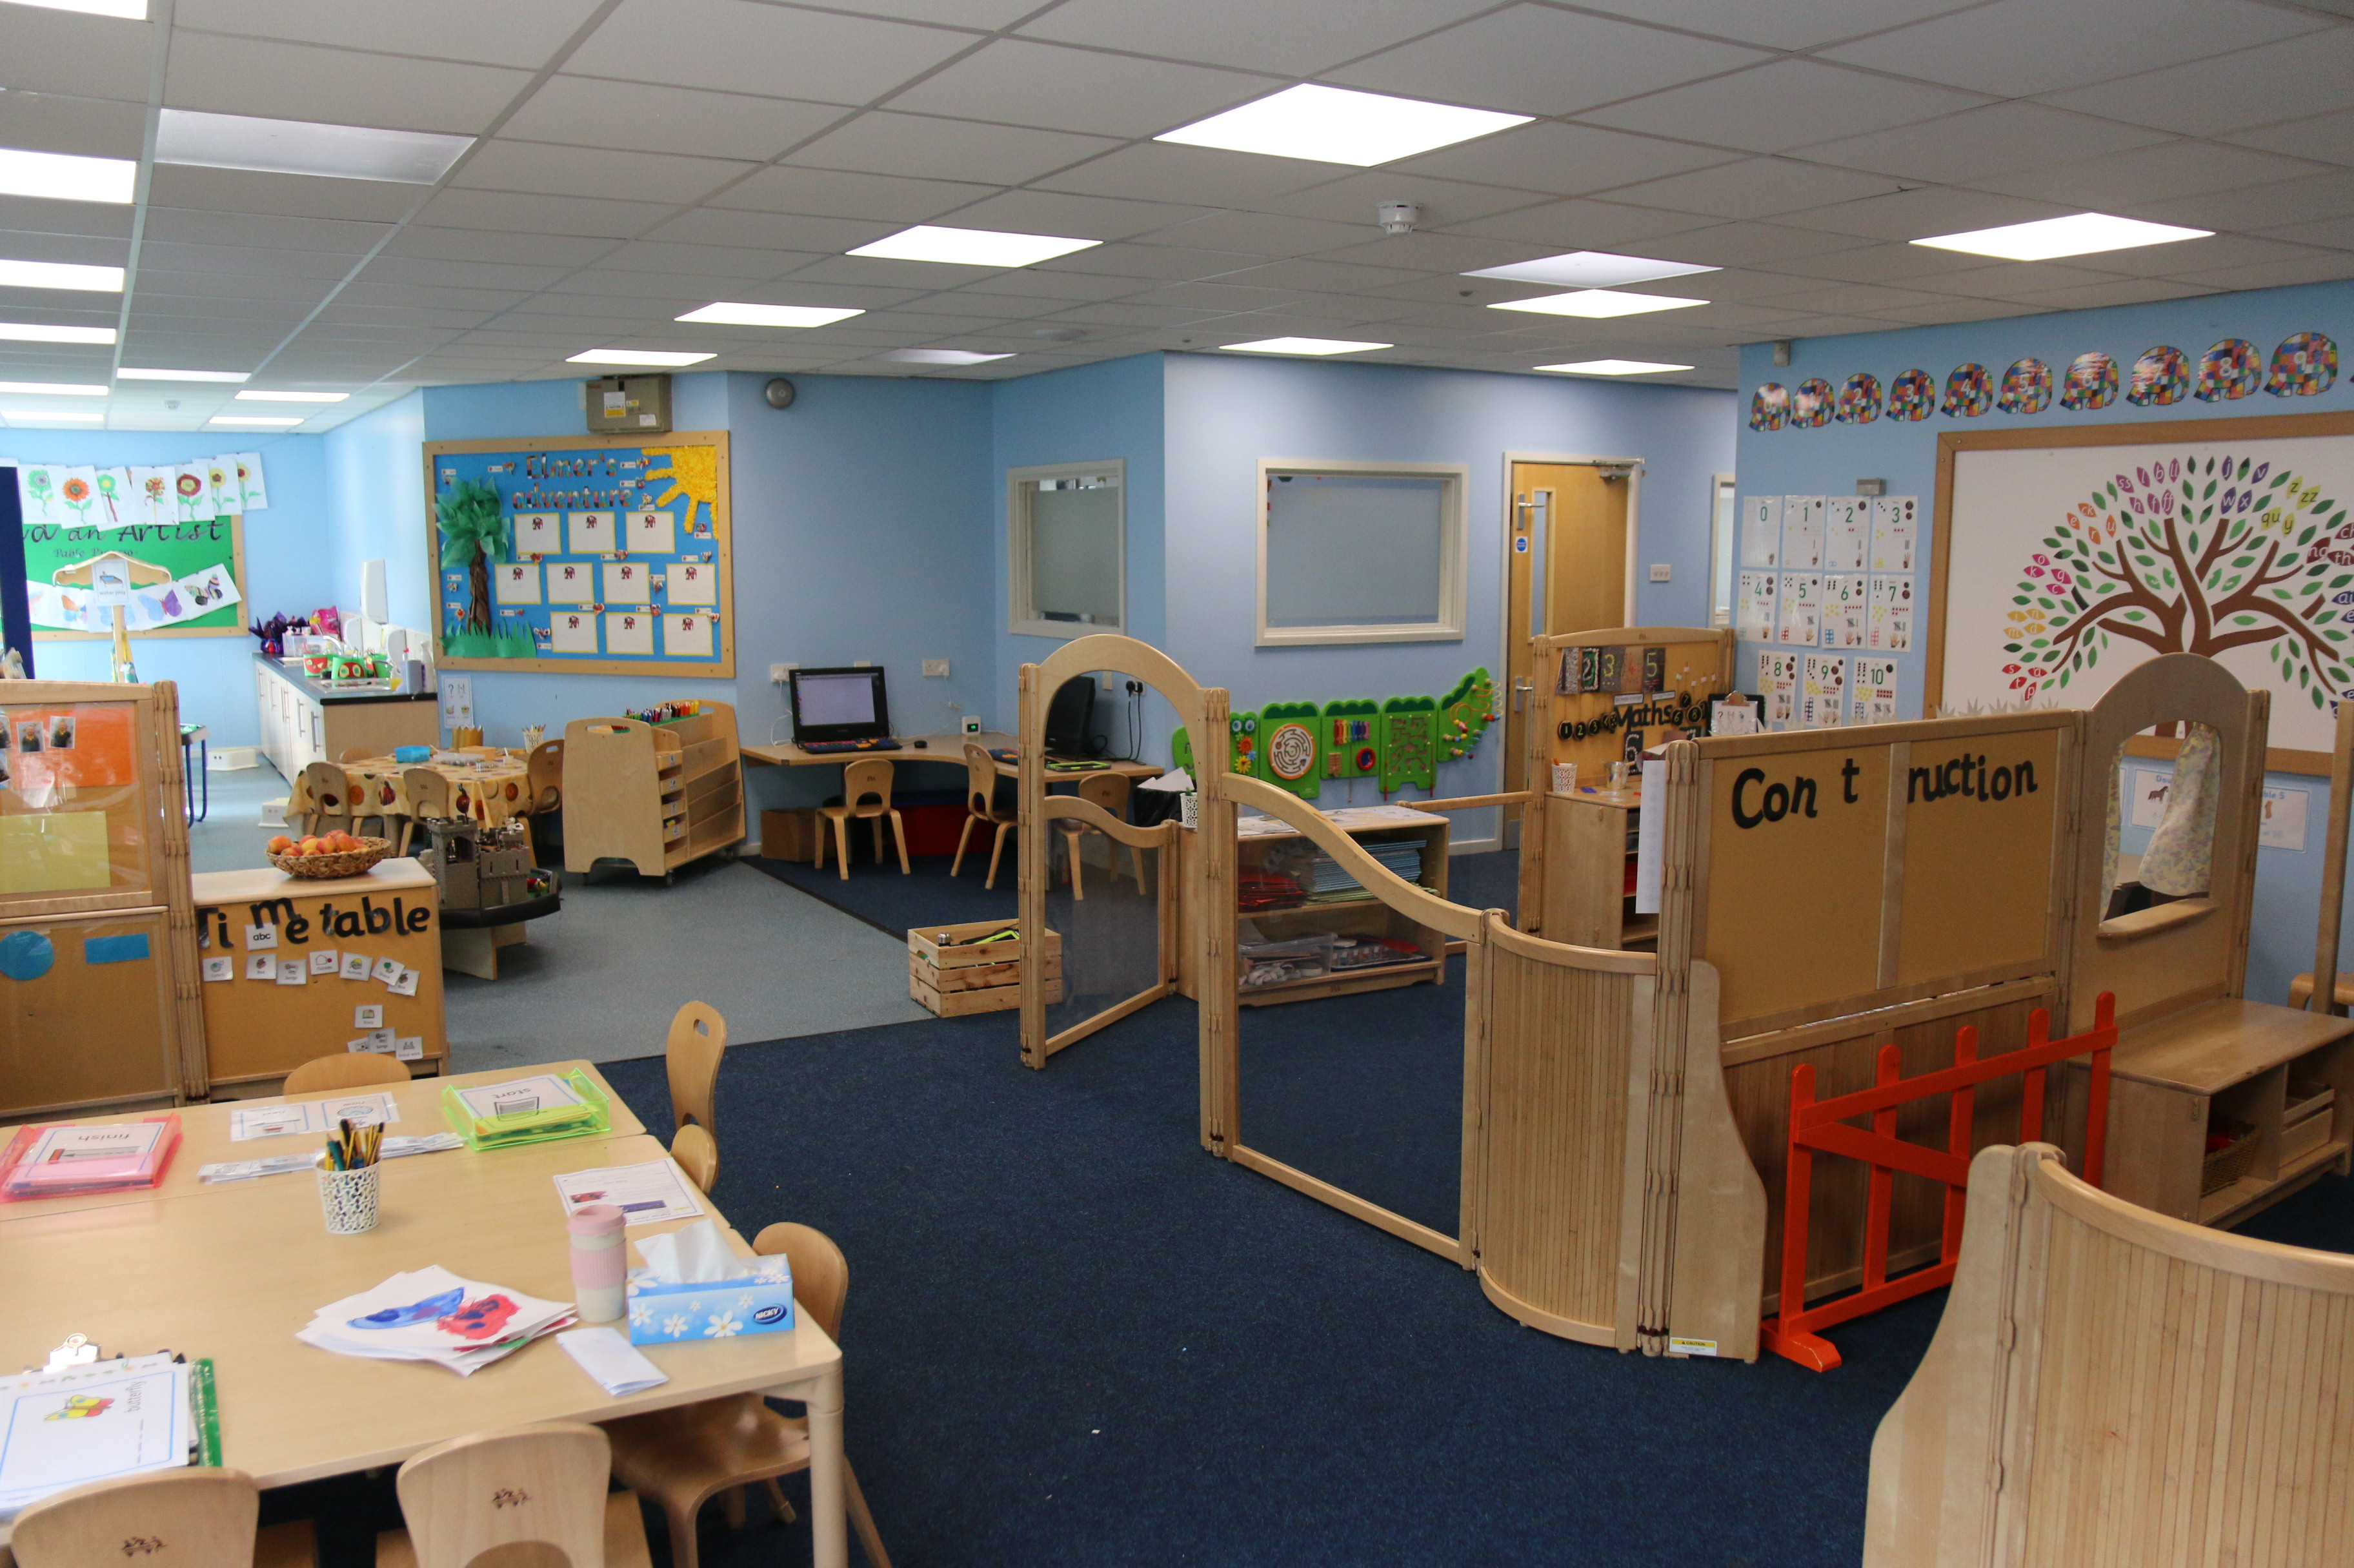  - All schools have their own distinctive ‘feel’ which makes each one unique. At Aughton, we believe that the feeling of being unique comes from our caring, supportive, and friendly learning environment.
Please note: The provision may look slightly different when your child starts in FS2 as it changes to reflect our curriculum and children’s interests.
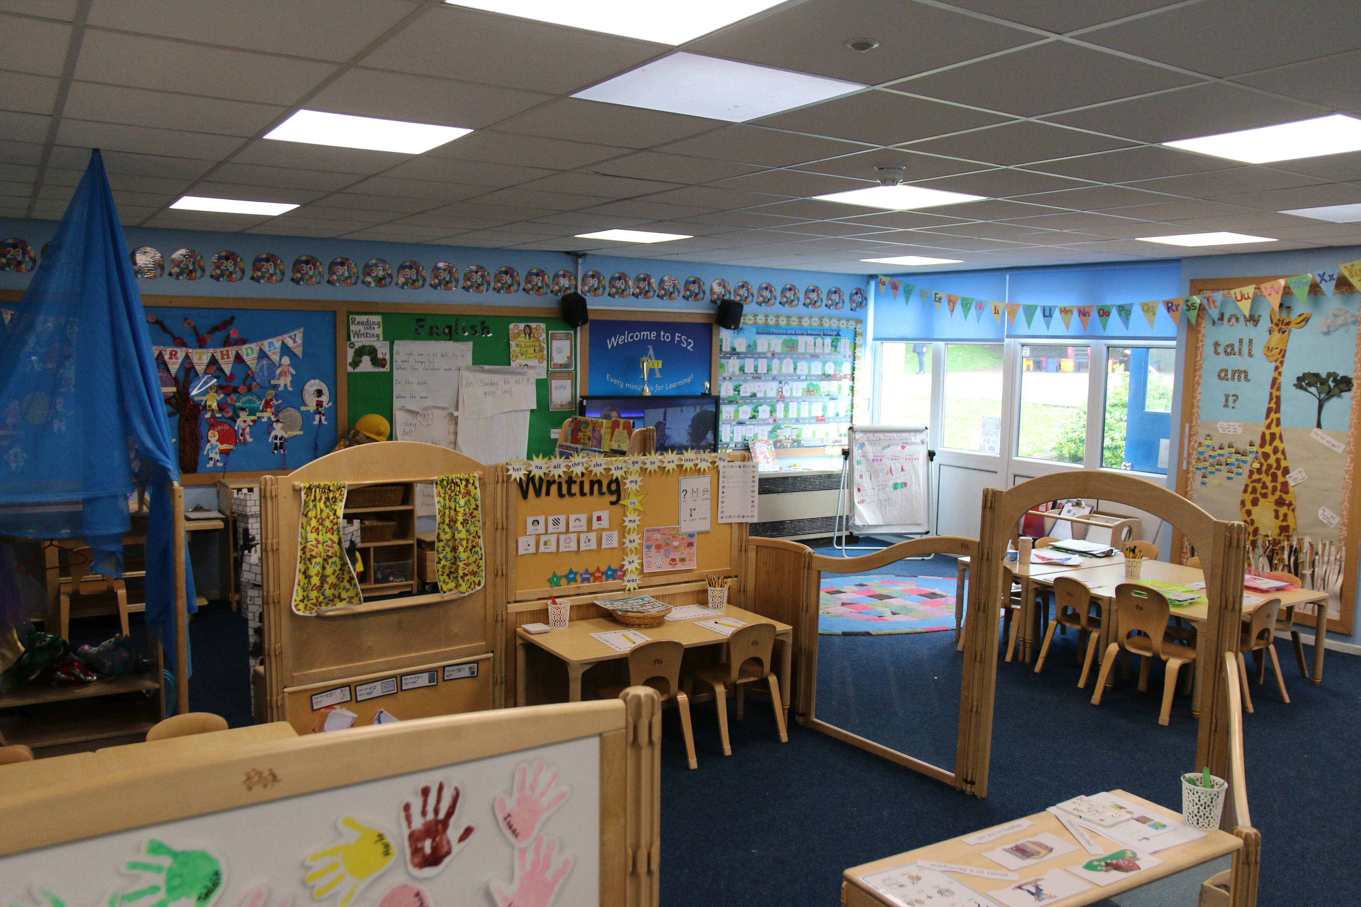  The Classroom  Our large Foundation Stage unit supports pupils to develop their characteristic of effective learning and the 7 aspects of the Early Years Foundation Stage in a play-based provision.  Play-based Provision  All the areas of learning are threaded through the activities provided for the children to access independently while being challenged. The children will take part in child-initiated and adult-led activities throughout the school day, both indoors and outdoors. | “I am really pleased with my child’s progress and the transition has been brilliant”  - FS Parent, Nov 2022  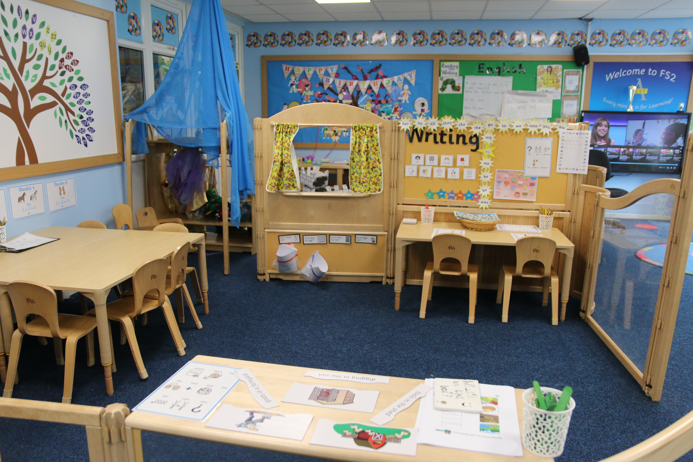  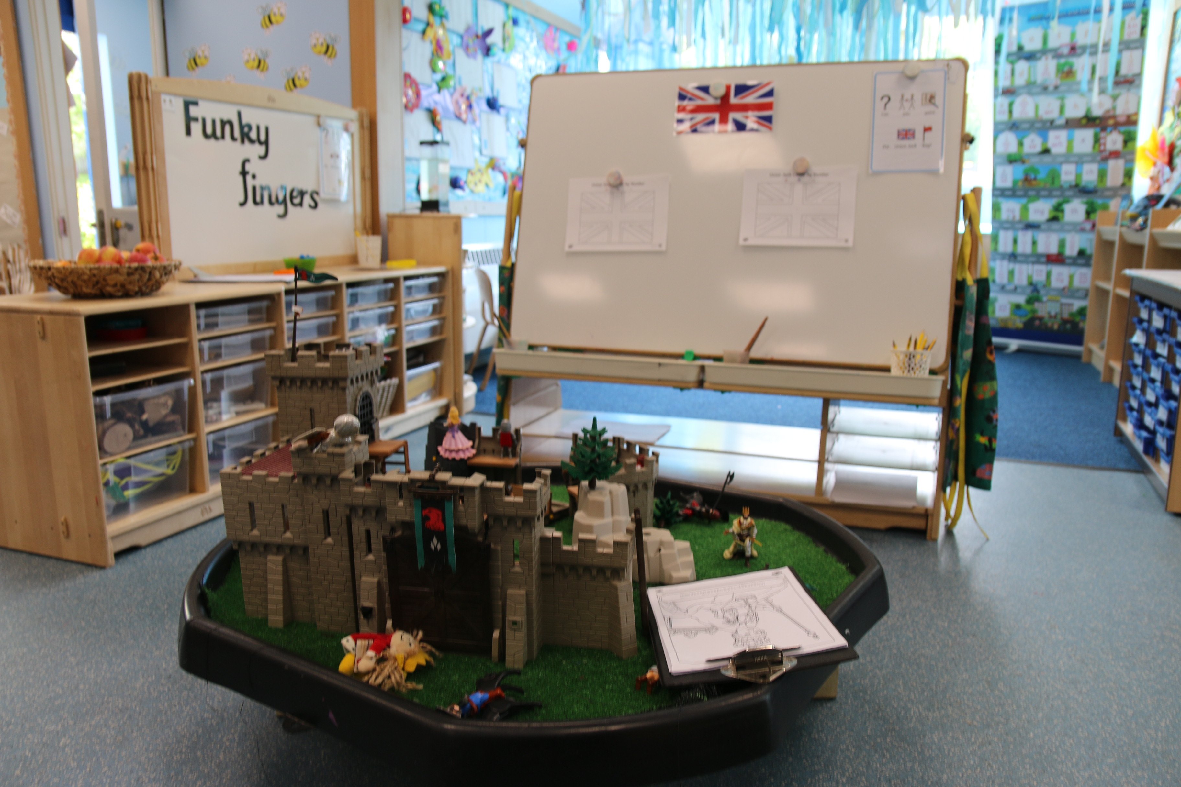 | Outdoor Learning Enviornment  

