
Aughton Junior Academy
Calculations Policy
DIVISION – FOUNDATION STAGE
Vocabulary | halve, half, share, share equally, split, groups
Method | Example
Understand how to halve a number using practical resources – splitting | 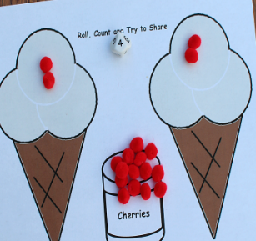  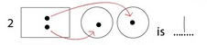  Sharing objects equally into 2 groups.  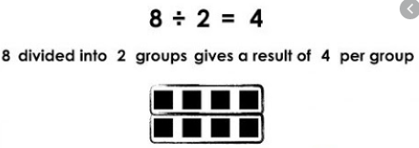
Solve problem including halving and sharing. | 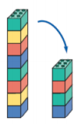  What is half of 8?  Half of 8 is 4

DIVISION – YEAR 1
Vocabulary | halve, share, share equally, groups, equal groups of, divide, divided by, left, left over
Method | Example
Recognise that ‘half’ is ÷ 2, meaning splitting into 2 equal parts. | 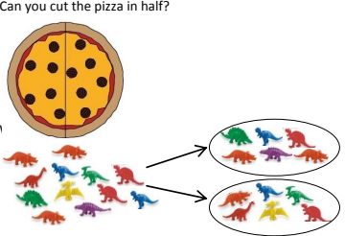
Understand division as sharing items equally between groups. | 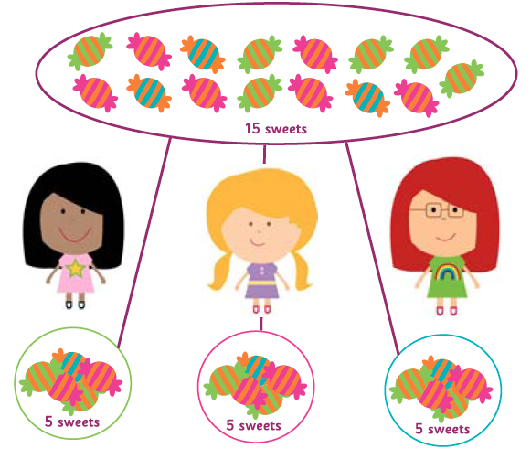
Recognise and write the division symbol (÷), using concrete objects to support calculations. | 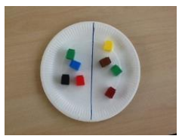  8 ÷ 2 = 4

DIVISION – YEAR 2
Vocabulary | groups of, equal groups of, halve, share, share equally, divide, divided by, divided into, repeated subtraction, inverse
Method | Example
Recognise division as repeated subtraction on a number line. | 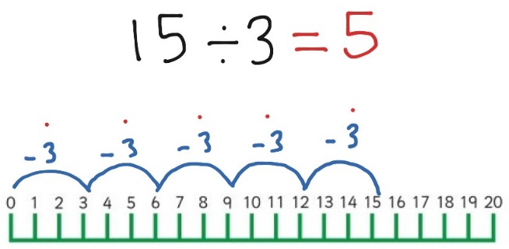
Use arrays within division to recognise how many equal groups. | 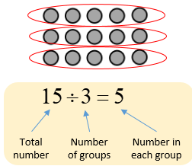
Children to understand the difference between sharing and grouping. | Sharing – 15 shared by 5  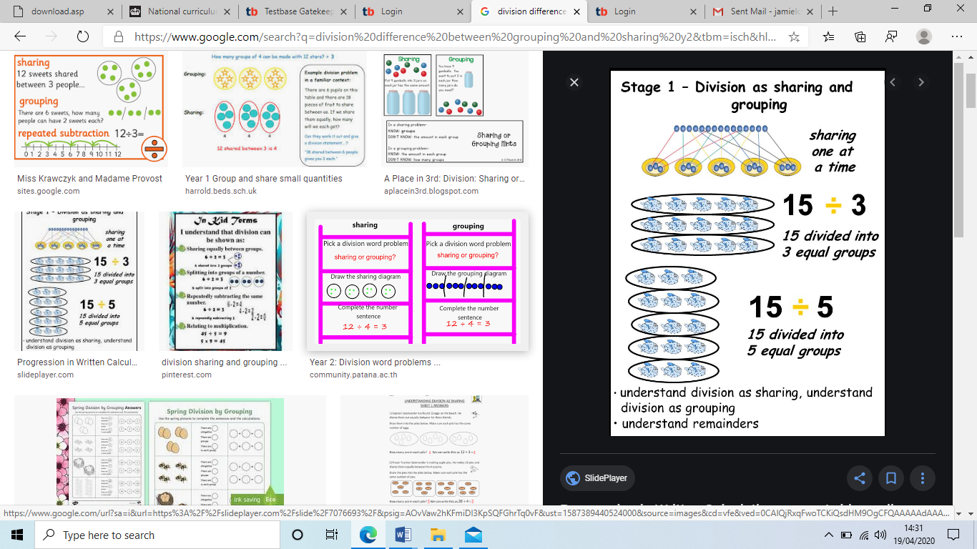  Grouping – 15 split into 5 equal groups
Use understanding of division to answer reasoning problems. | 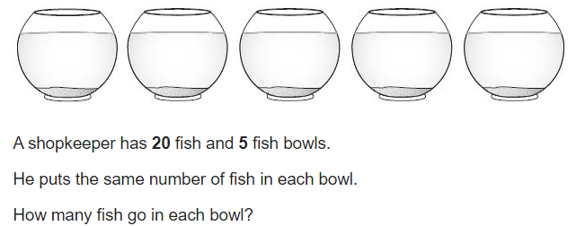

DIVISION – YEAR 3
Vocabulary | divided by, divide, divided into, grouping, divisor, short division, remainder, inverse
Method | Example
Know division facts for 2s, 5s, 10s, 3s, 4s and 8s. | 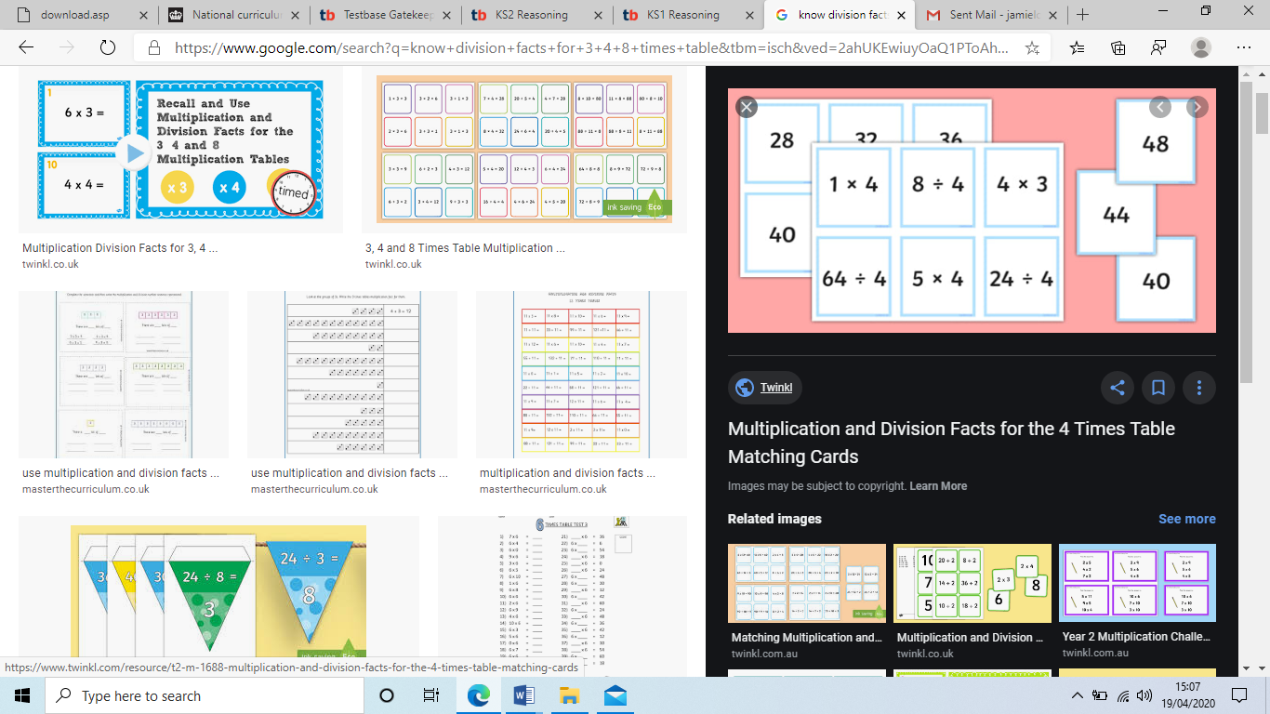
Understand halving through partitioning. | 68 = 60 + 8  Half = 30 + 4 = 34
Use practical resources to find groups of tens and ones, in 2-digit numbers, without remainders. | 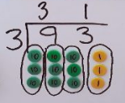
Use practical resources to find groups of hundreds, tens and ones, in 3-digit numbers, without remainders. | 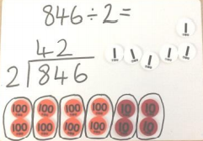  3
Recognise remainders within division. | 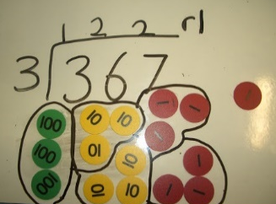
Use understanding of division to answer reasoning problems. | 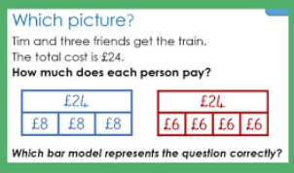

DIVISION – YEAR 4
Vocabulary | factor, divisor, divided by, divided into, remainders, divisible by, equivalent, short division, derive, Quotient, inverse, remainder, multiples, exchange.
Method | Example
Children to use practical resources to support use of short division, inc. remainders. | 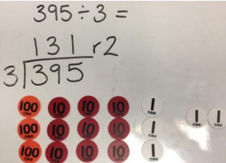
Children to use practical resources to support use of short division, inc. exchanging. | 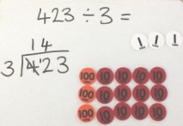  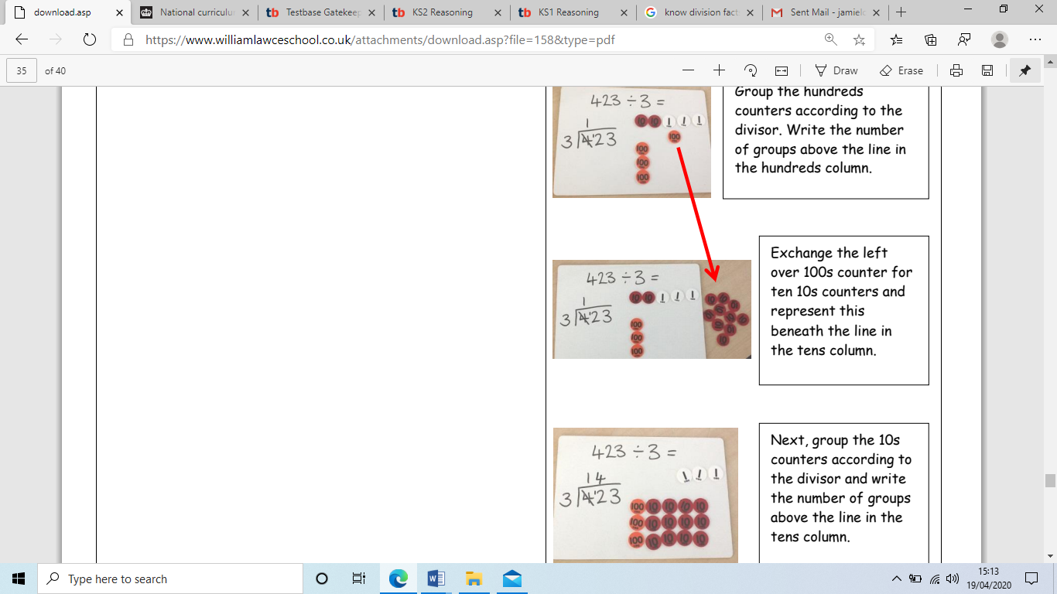  Children to become increasingly confident and move away from resources.
Divide numbers by 10/100 | 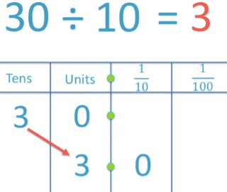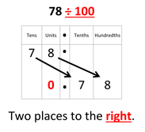
Use understanding of division to answer reasoning problems. | 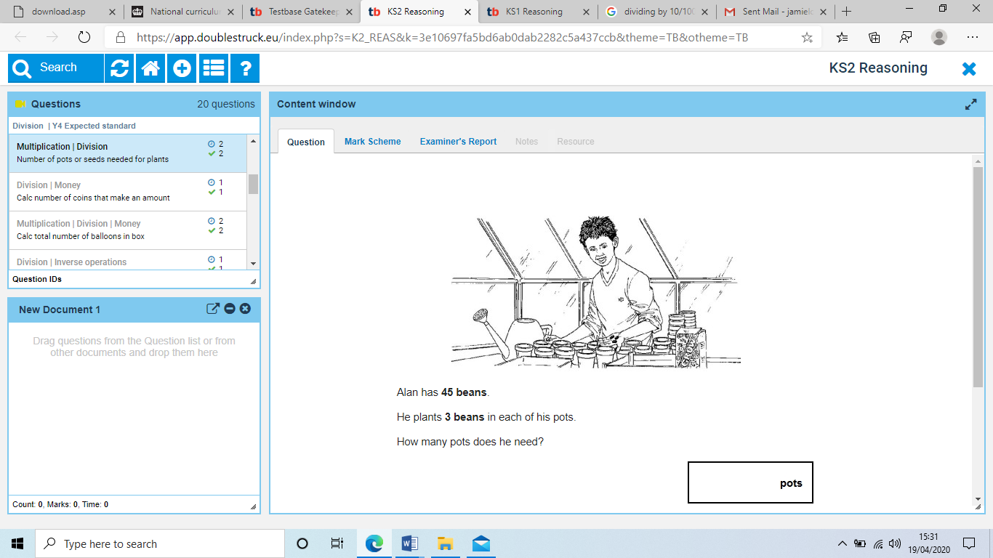  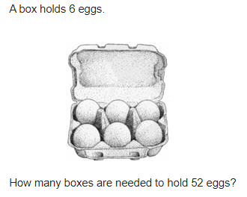

DIVISION – YEAR 5
Vocabulary | divide, divided by, divided into, divisible by, remainder, quotient, inverse, decomposing, factor, decimal place, units, tenths, scaling, short division.
Method | Example
Children to become increasingly confident using short division. | 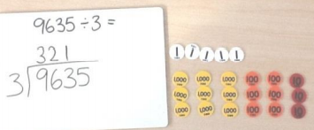  1 r 2
Short division, including exchanging. | 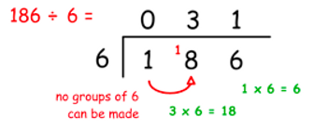
Dividing decimals by 10/100/1000 | 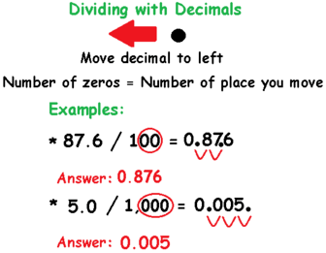
Use understanding of division to answer reasoning questions | 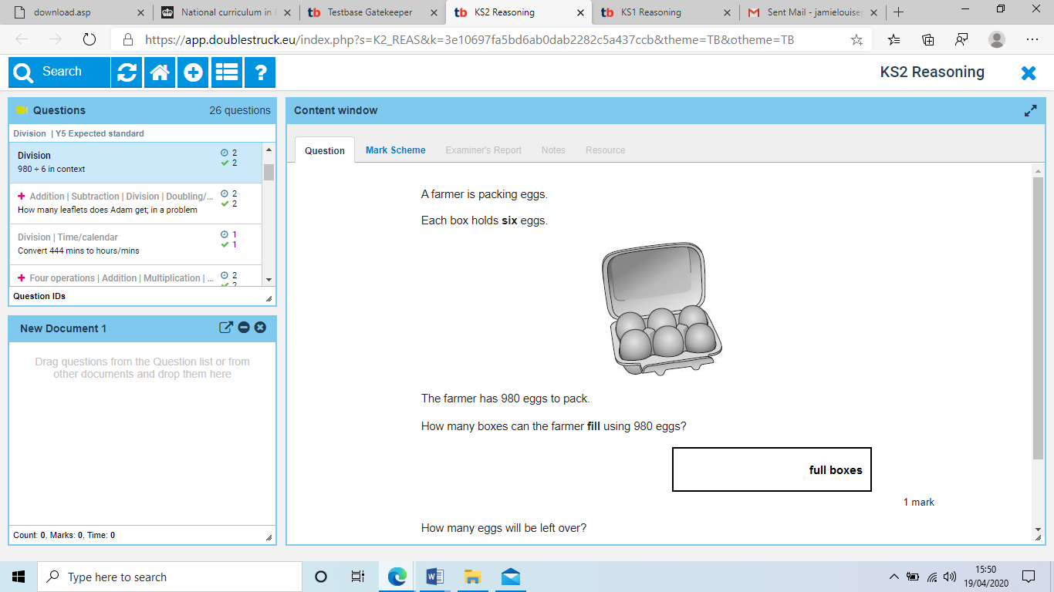  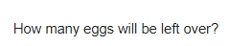

DIVISION – YEAR 6
Vocabulary | divide, divided by, divided into, divisible by, remainder, factor, quotient, inverse, decimal place, units, tenths, hundredths, scaling, formal written methods.
Method | Example
Formal long division | 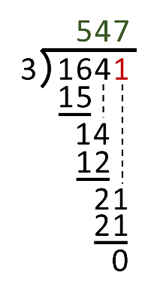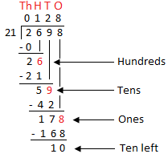  r 10  21  21 +  42  21 +  63  21 +  84  Etc.  (unknown multiplication tables to be written down the side)
Long division inc. decimals. | 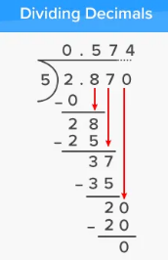
Divide decimals by 10/100/1000 | 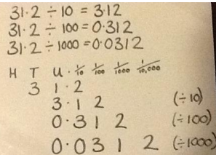
Use understanding of division to answer reasoning questions | 

