
Aughton Junior Academy
Calculations Policy
MULTIPLICATION – FOUNDATION STAGE
Vocabulary | Group, lots of, double, twice
Method | Example
Use practical resources to count in 2s and 10s. | 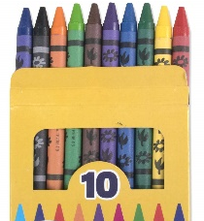  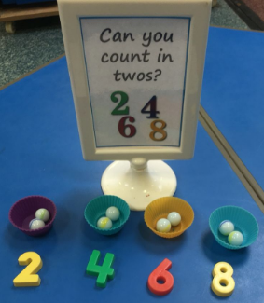  10 20 30
Understand how to double a number using practical resources. | 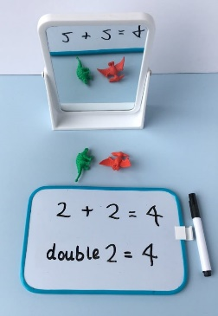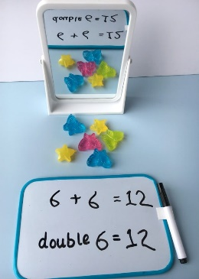

MULTIPLICATION – YEAR 1
Vocabulary | odd, even, count in twos, fives, count in tens, lots of, groups of, times, multiply, multiply by, array, row, column, half, double, once, twice, five times, ten times, multiple of  How many times?
Method | Example
Count in 2s, 5s and 10s, using practical objects. | 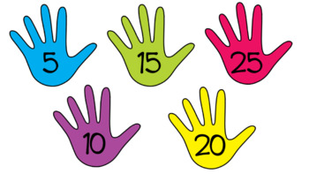    6  4  2  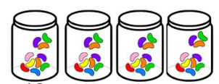  40  30  20  10
Recognise patterns of numbers within the 2, 5 and 10 times table. | 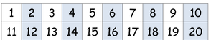  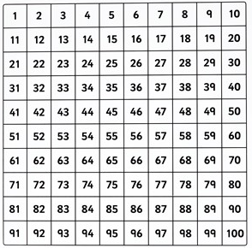  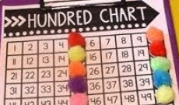
Use arrays to understand multiplication through repeated addition. Introducing the ‘x’ symbol | 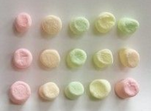  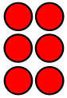  3 x 2 = 6 3 x 5 = 15  (2+2+2) (5+5+5)
Use understanding of multiplication to answer reasoning questions. | 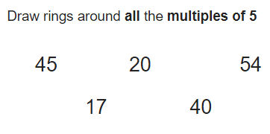  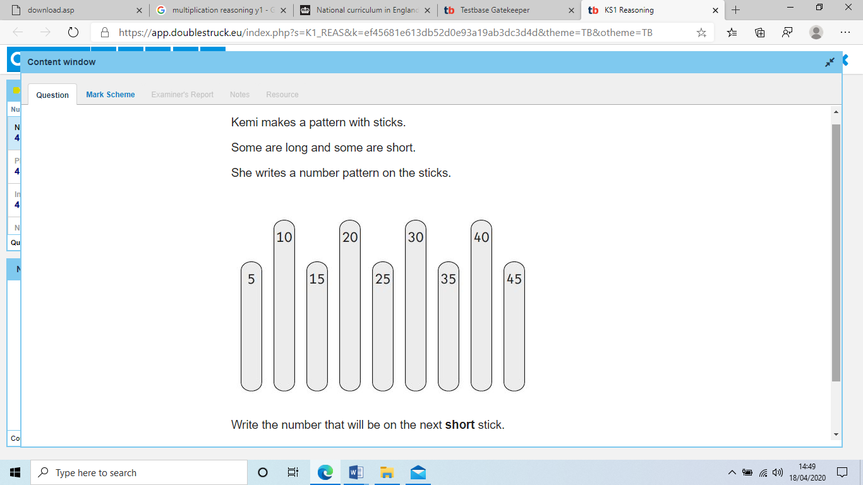

MULTIPLICATION – YEAR 2
Vocabulary | odd, even, twos, fives, tens, threes, lots of, groups of, once, twice, three times, five times, ten times, multiple of, times, multiply, multiply by, repeated addition, array, row, column, double.  How many lots of?  How many times bigger?
Method | Example
Count in 2s, 5s, 10s and 3s. Recognising the patterns they make. | 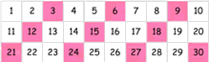  12  9  6  3
Use arrays to understand multiplication through repeated addition.  Using the ‘x’ symbol to write number sentences | 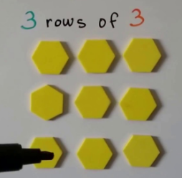  3 x 3 (three lots of 3)  3 + 3 + 3 = 9
Recognise that multiplication is commutative.  (can be done in any order) | 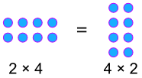
Understand multiplication as repeated addition using grouping. | 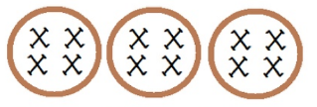  4 x 3 = 12
Recognise multiplication as repeated addition on a number line. | 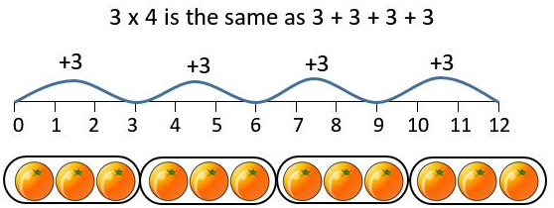
Use understanding of multiplication to answer reasoning problems. | 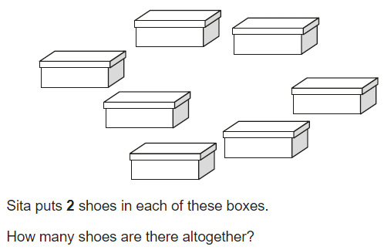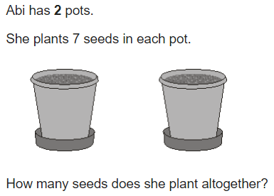

MULTIPLICATION – YEAR 3
Vocabulary | multiply, times, groups of, equal groups of, multiple of, multiplied by, estimate, inverse, grid multiplication, expanded column multiplication, partition, commutative, associative, product.
Method | Example
Know multiplication facts for 2s, 5s, 10s, 3s, 4s and 8s.  Recognising the relationship between 2s, 4s and 8s through doubling. | 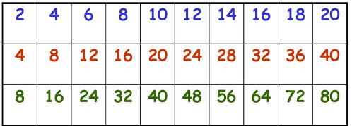  double  double
Understand doubling through use of partitioning. | 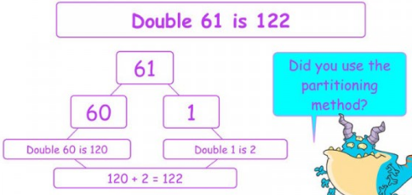
Use understanding of repeated addition and partitioning to answer 2-digit multiplication. | 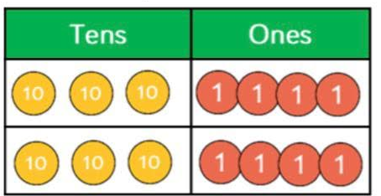  34 x 2  34 x 2  30 + 4  30 + 4  60 + 8 = 68  60 + 8 = 68
Understand grid method multiplication, using prior learning of partitioning. | 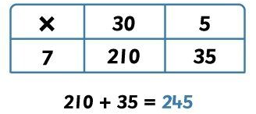  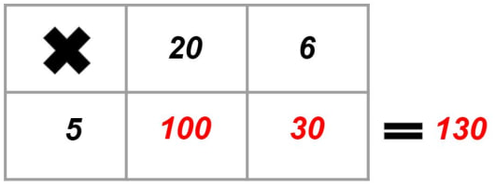
Use partitioning to break 2-digit by 1-digit multiplication into smaller problems.  (Distributive law) | 24 x 7  24 = 20 + 4  20 x 7 = 140  4 x 7 = 28 +  168
Use understanding of multiplication to answer reasoning questions. | 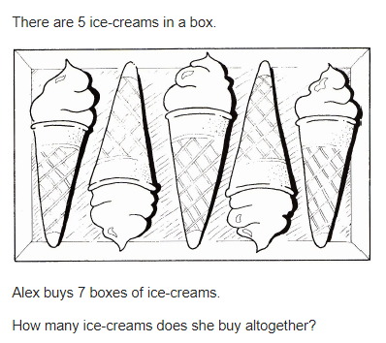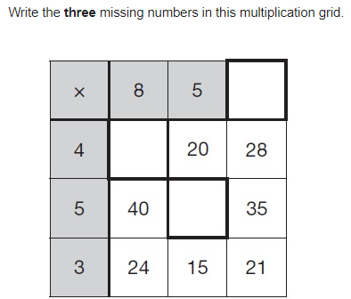

MULTIPLICATION – YEAR 4
Vocabulary | multiply, multiplied by, product, short multiplication, partition, distributive law, factors, carry, commutative, groups of, multiply, times, multiples, inverse.
Method | Example
Know all multiplication facts to 12 x 12 | 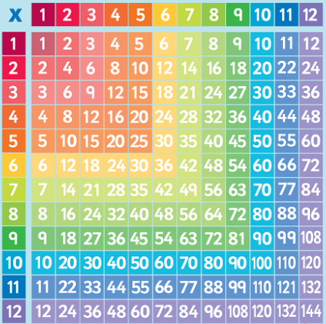
Understand expanded multiplication, focusing on carrying digits that exceed 10. | 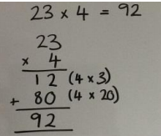  Starting with the ones,  4 x 3 = 12  Then tens,  4 x 2 (20) = 80  80 + 12 = 92
Use formal methods of short multiplication, focusing closely on carrying. | 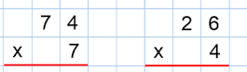  1 0 4  2  2  5 1 8
To use understanding of multiplication to answer reasoning problems. | 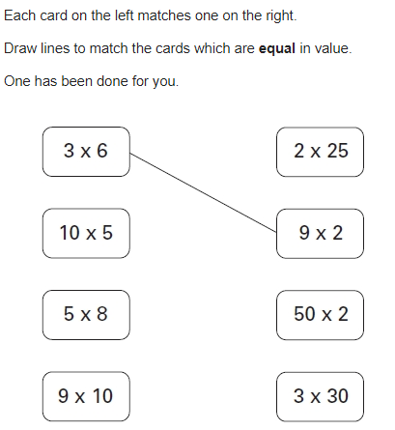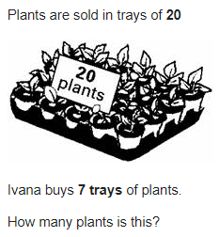

MULTIPLICATION – YEAR 5
Vocabulary | composite numbers, prime number, prime factor, cube number, square number, derive, factor pairs, formal written method, times, multiply, lots of, multiplied by, multiple of, product, short multiplication, partition, long multiplication, scaling, decimal place, units, tenths and hundreds.
Method | Example
Short multiplication  2-digit x 1-digit  3-digit x 1-digit  4-digit x 1-digit | 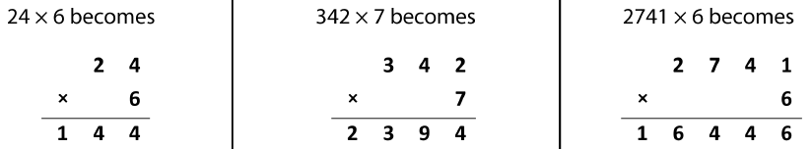  1  4  2  1  2  2
Long multiplication  2-digit x 2-digit  3-digit x 2-digit  4-digit x 2-digit | 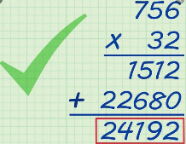  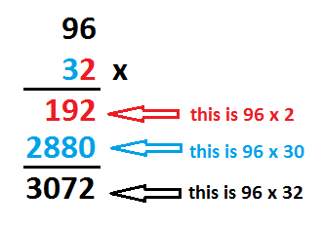  Remembering 0 place holder, because 2nd digit is 30 not 3  1
Multiplying decimals by 10/100/1000. | 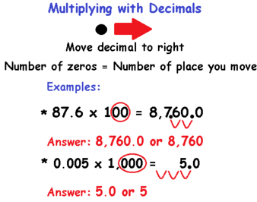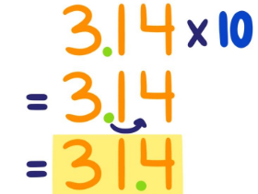
Use understanding of multiplication to answer reasoning questions | 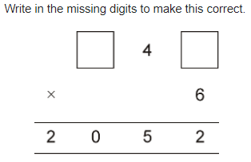  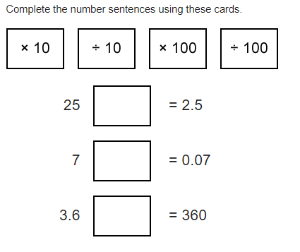

MULTIPLICATION – YEAR 6
Vocabulary | common factors, multiples, prime, formal written method, multiply, multiplied by, multiple of, product, short and long multiplication, partition, scaling, decimal place, units, tenths and hundredths.
Method | Example
Multiplying decimals by 10/100/1000. | 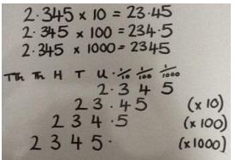
Long multiplication  3-digit x 2-digit  4-digit x 2-digit | 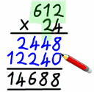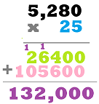
Multiply decimals up to two decimal places by a whole number. | 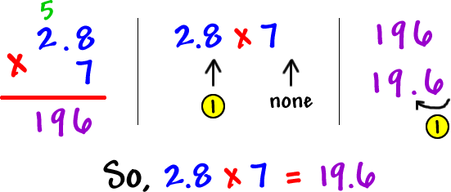  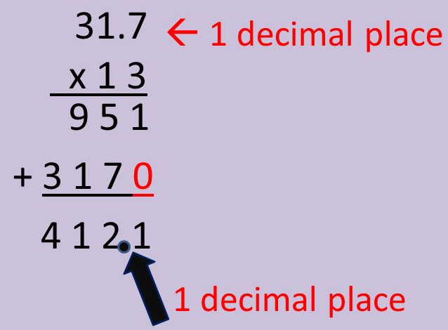
Use understanding of multiplication to answer reasoning questions | 

