
Aughton Junior Academy
Calculations Policy
SUBTRACTION – FOUNDATION STAGE
Vocabulary | Take, take away, less, leave, difference between, one less, two less, ten less, count back, subtract, subtraction  How many fewer is _?  How many have gone?  How many are left/left over?
Method | Example
Use practical resources to take objects away, using touch counting.  “How many are left?” | 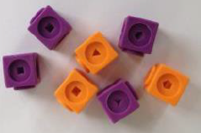  7 – 3 =  4
Introduce the - symbol for subtraction, subtracting using pictorial representations | 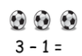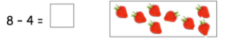
Counting back on fingers, for ‘taking away’ | 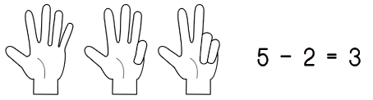
Introduce = symbol for writing simple subtraction sentences. | 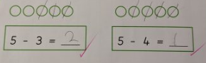
Use a number line for subtraction, jumping backwards in 1s. | 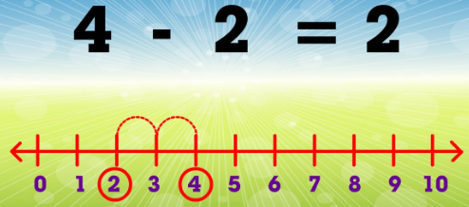

ADDITION – YEAR 1
Vocabulary | Subtract, subtraction, take away, minus, leave, half, halve, one less, two less, ten less, count back, difference between, inverse  How many fewer is _ than _?  How much less is _?  How many are left over?  How many are gone?  How many more is _ than_?
Method |   Example
Practical subtraction, using objects and touch counting, including crossing the tens boundary. | 12 – 4 = 8
Use a number line for subtraction, jumping back in 1s, including crossing the tens boundary | 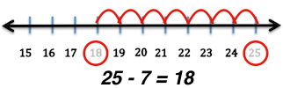
Use understanding of subtraction to answer simple missing number questions. | 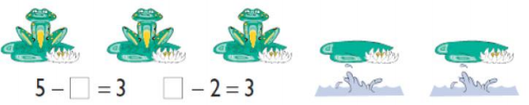
Understand the relationship between addition and subtraction, knowing this as the inverse. | 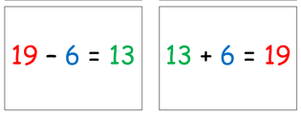
Use understanding of subtraction to solve reasoning questions | 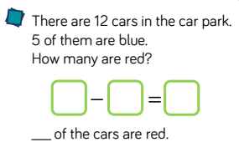  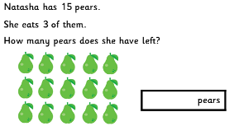

ADDITION – YEAR 2
Vocabulary | Subtract, subtraction, take away, minus, leave, half, halve, one less, two less, ten less, count back, difference between, inverse, partition, exchange  How many fewer is _ than _?  How much less is _?  How many are left over?  How many are gone?  How many more is _ than_?
Method | Example
Use concrete objects and pictorial representations to subtract:  2-digit and 1-digit numbers  2-digit and 2-digit numbers  2-digit & multiple of 10  three 1-digit numbers | 27 – 9  18
Use a number line, once a number has been partitioned, to subtract two 2-digit numbers | 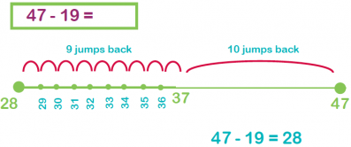  Partition 2nd number  19 = 10 + 9  Starting at 47  Jump back 1 ten  Then 9 ones
Use concrete objects to visually represent column subtraction, in order to develop understanding. | 35 - 17  Partition 2nd number  17 = 10 + 7  Subtract units from 1st number  (if there isn’t enough then exchange 1 tens stick for 10 ones)  So now 35 = 20 + 15  Continue to subtract units  15 – 7 = 8  Then subtract tens  20 – 10 = 10  10 + 8 = 18
  T | O
  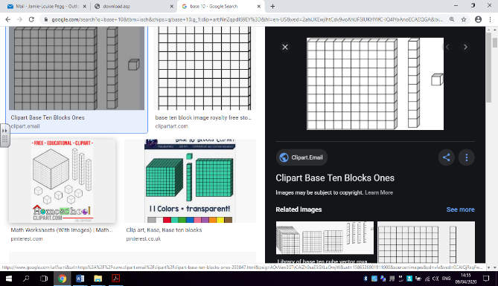
  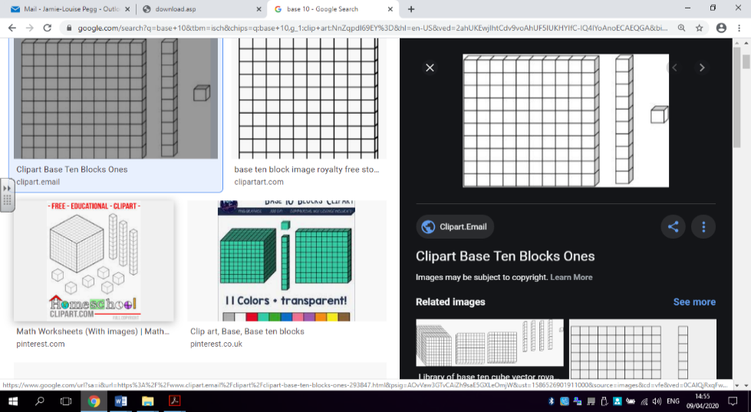
  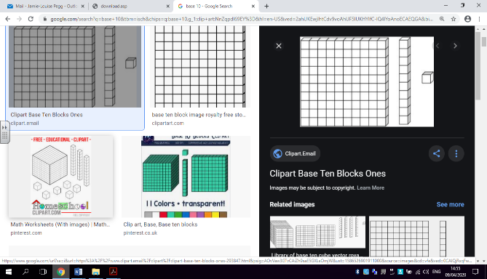
Use column subtraction, ensuring tens and units correctly aligned, including exchanging. | 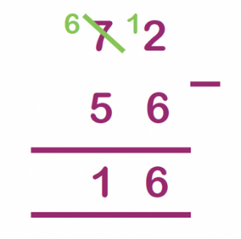  Once correctly aligned,  Always begin with the ones 2 – 6 (not possible)  So we need to exchange 1 ten for 10 ones  (as in practical done previously)  We now have 12 ones  12 – 6 = 6  Because 1 ten was exchanged, we now have 6 tens left.  6 – 5 = 1 (tens) (60 – 50 = 10)  10 + 6 = 16
Use understanding of subtraction to answer reasoning problems. | 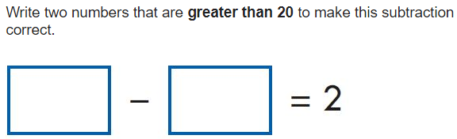  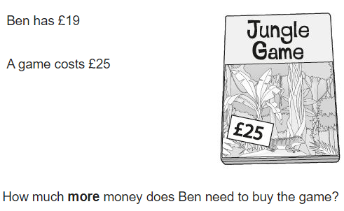

ADDITION – YEAR 3
Vocabulary | Subtract, subtraction, take away, minus, leave, half, halve, one less, two less, ten less, count back, difference between, inverse, partition, exchange, column subtraction.  How many fewer is _ than _?  How much less is _?  How many are left over?  How many are gone?  How many more is _ than_?
Method | Example
Use a number line, once a number has been partitioned, to subtract numbers up to 3 digits. | 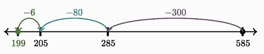  585 – 386  Partition the 2nd number  386 = 300 + 80 + 6  Starting at 585  Jump back 300  Jump back 80  Jump back 6
Use column subtraction, including exchanging tens and hundreds. | 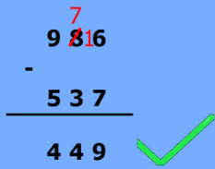  Once correctly aligned,  Always begin with the ones 6 – 7 (not possible)  So we need to exchange 1 ten for 10 ones  We now have 16 ones  16 – 7 = 9  Because 1 ten was exchanged, we now have 7 tens left.  7 – 3 = 4 (tens) (70 – 30 = 40)  Finally, 9 – 5 = 4 (hundreds) (900 - 500 = 400)  400 + 40 + 9 = 449
Understand the relationship between addition and subtraction, knowing this as the inverse, to check calculations. | 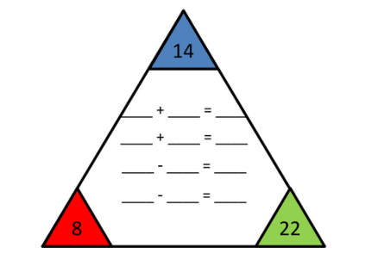  14 + 8 = 22  22 – 8 = 14  22 – 14 = 8
Use understanding of subtraction to answer reasoning problems. | 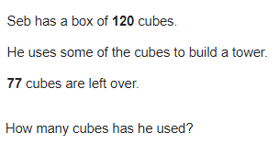  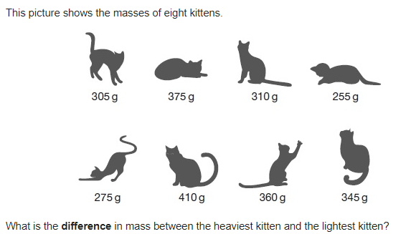

ADDITION – YEAR 4
Vocabulary | Subtract, subtraction, take away, minus, leave, half, halve, one less, two less, ten less, count back, difference between, inverse, partition, exchange, column subtraction, decrease.  How many fewer is _ than _?  How much less is _?  How many are left over?  How many are gone?  How many more is _ than_?
Method | Example
To use a number line, once a number has been partitioned, to subtract numbers up to 4 digits. Using increasing mental calculation. | 2345 - 632 (600 + 30 + 2)  -2  -30  -600  1713 1715 1745 2345
Use column method, focusing on aligning number correctly exchanging. | 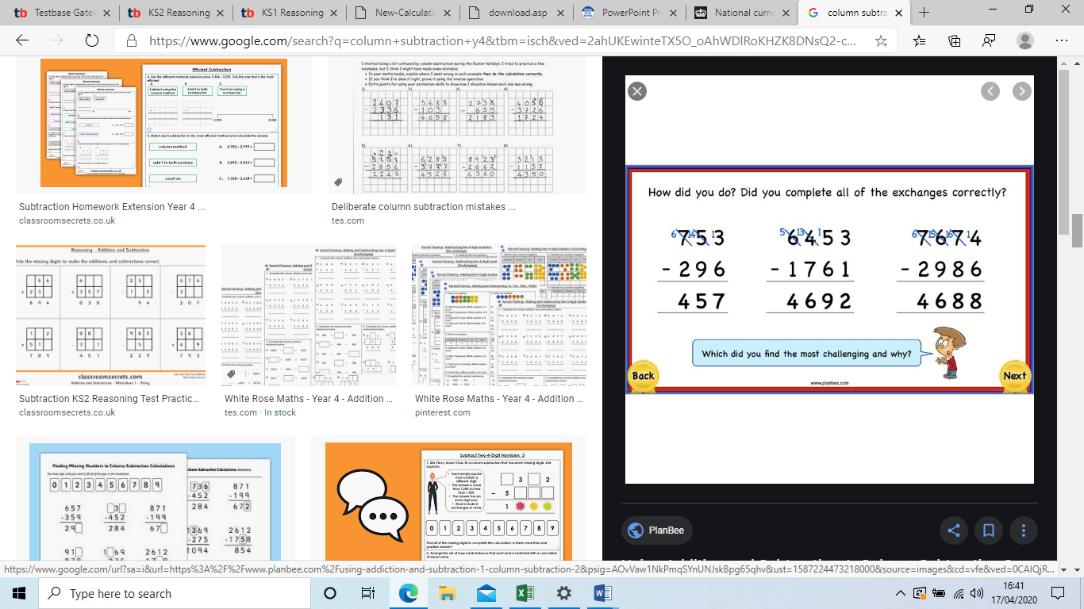
Use inverse to check calculations, recognising the relationship between addition and subtraction. | 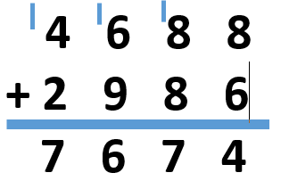
To use understanding of subtraction to answer reasoning problems, including 2 step problems. | 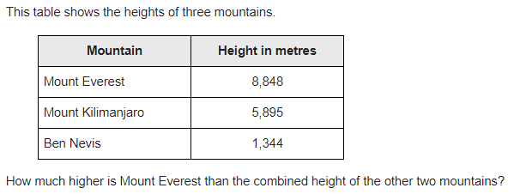

ADDITION – YEAR 5
Vocabulary | Subtract, subtraction, take away, minus, leave, half, halve, one less, two less, ten less, count back, difference between, inverse, partition, exchange, column subtraction, decrease, decimals, tenths, hundredths, formal method  How many fewer is _ than _?  How much less is _?  How many are left over?  How many are gone?  How many more is _ than_?
Method | Example
Column method, including exchanging with numbers up to 5-digits | 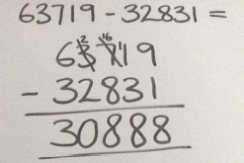  Ensuring all columns are correctly aligned,  focus on use of exchanging when the top value  is lower than the bottom value in any column.
Column method, using decimals, focusing on the decimal alignment. | 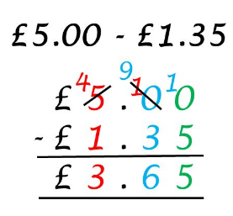  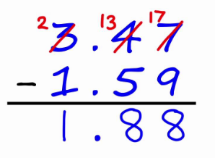  Decimals must be aligned correctly,  any gaps should be filled with an  empty place holder (0),  0  then proceed to use column subtraction,  remembering to exchange when needed.  Ensure to also include the decimal  in the answer.  Any number that contains no decimal  5 = 5.00
Use understanding of subtraction to answer reasoning questions | 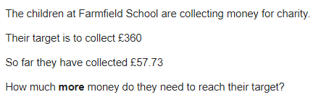

ADDITION – YEAR 6
Vocabulary | Subtract, subtraction, take away, minus, leave, half, halve, one less, two less, ten less, count back, difference between, inverse, partition, exchange, column subtraction, decrease, decimals, tenths, hundredths, formal method  How many fewer is _ than _?  How much less is _?  How many are left over?  How many are gone?  How many more is _ than_?
Method | Example
Column method, using multiple numbers. | 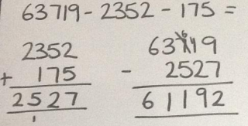  Ensuring all columns are correctly aligned,  focus on use of exchanging when the top value  is lower than the bottom value in any column.  When subtracting more than one number,  subtract one first then subtract the second  from the answer.
Column method, using decimals, ensuring to align decimals correctly. | 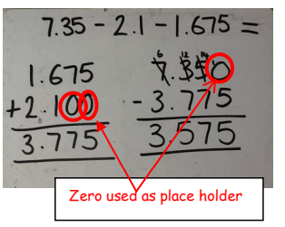  Decimals must be aligned correctly,  If a number has no decimal, then add .000  e.g. 24 = 24.000  any gaps should be filled with an empty place  holder (0),  then proceed to use column subtraction,  Remembering to exchange when needed.  Ensure to also include the decimal in the answer
Use understanding of addition to answer reasoning questions | 

